TOUBLESHOOTING PRACTICE #1 CS1310 Dr. Redfield
Heart Rate Calculator

Name: Weiss Del Carmen

Instructions:
The output for the program (when working correctly) is shown below. A number of errors have been put into the code. Use the chart below to indicate the errors as you find them. The code (with errors) is shown after the output; however, it would be easiest for you to run the program and make use of the error messages to troubleshoot. There are between 3 and 10 errors. You should be able to reproduce the output below once all the errors have been corrected.

Program: ts1_Heart_Rate_Calculator.c

Line # Error

25 undefined reference to ‘print’

30 expected ‘;’ before ‘printf’

37 missing ‘, max’ in the ‘printf’

Output:
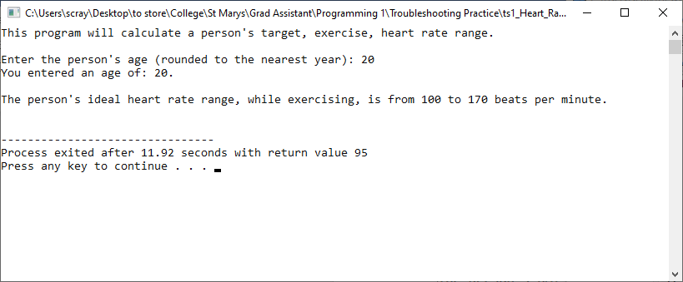

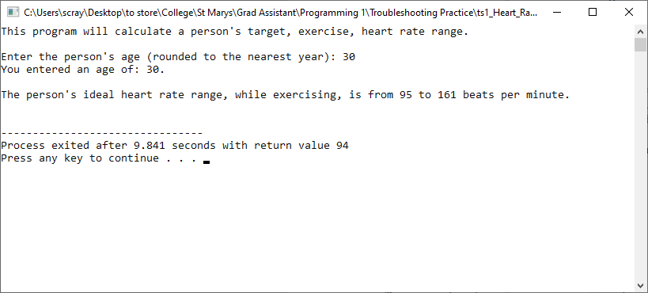

Code:
/* ==========================================================================
Troubleshooting Practice #1
Description: This program calculates a person's target exercise heart
rate range: min = 50% of max heart rate
max = 85% of max heart rate
max heart rate = 220 - age
NOTE: even though percentages typically have decimal places the program
uses integers as heart beats are normally referred to in whole numbers.

Author: Scott Raymond
Date: 29 Aug 2020
Language: C
For Class: CS1310, Programming I
===========================================================================*/
#include <stdio.h>
#define MAXBEATS 220 /* max beats per minute */

void main(void)
{
int age; /* the person's age */
int min; /* lower end of heart rate range */
int max; /* upper end of heart rate range */
int maxHeartRate; /* the person's max heart rate */

print("This program will calculate a person's target, exercise"
", heart rate range.\n\n");

printf("Enter the person's age (rounded to the nearest year): ");
scanf("%d", &age)
printf("You entered an age of: %d.", age);

/* calculate maxHeartRate and the min and max target rates */
maxHeartRate = MAXBEATS - age;
min = maxHeartRate * .50;
max = maxHeartRate * .85;

printf("\n\nThe person's ideal heart rate range, while exercising, "
"is from %d to %d beats per minute.\n\n", min);

}

